01_Discover_Master Template - 1 Dimension (VLookup)
Report Views
Standard View
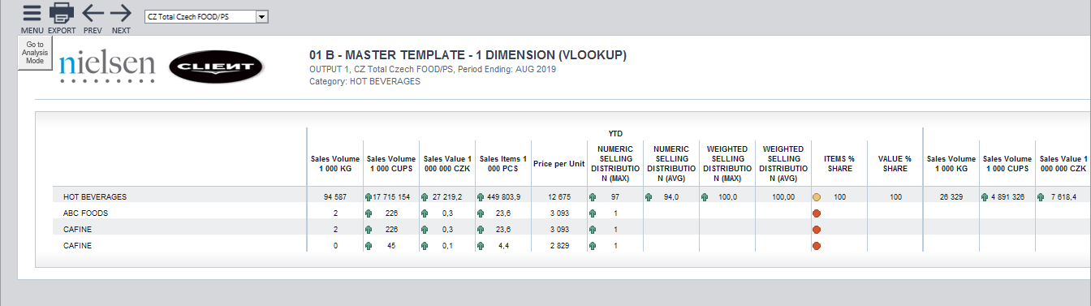
Standard View
Guidelines
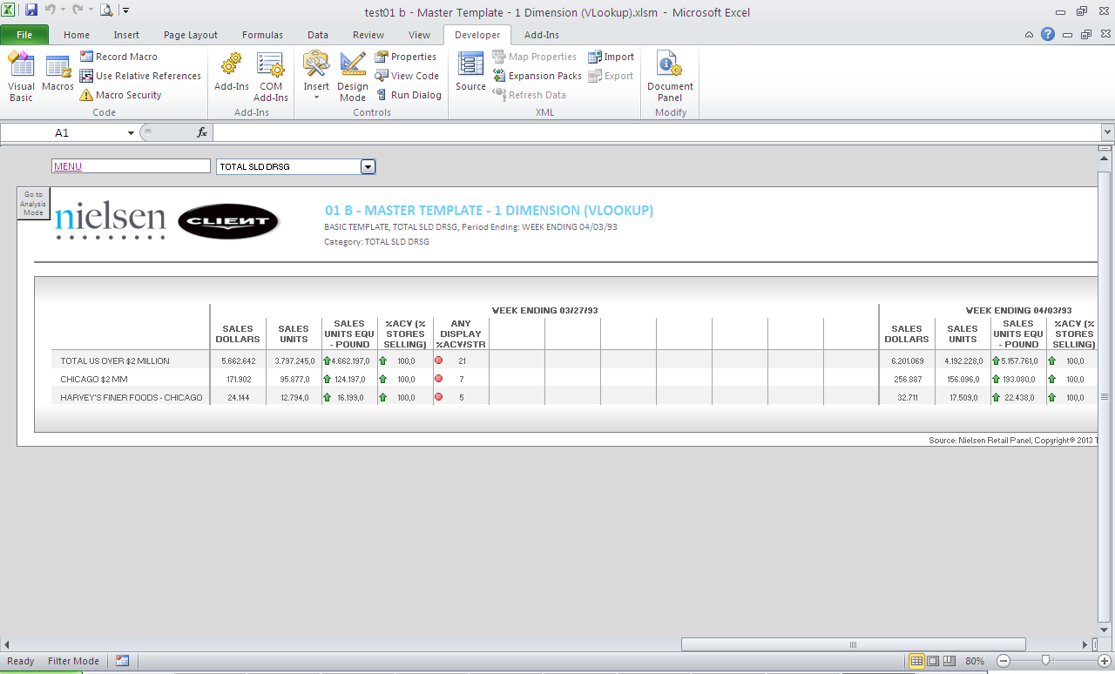
Template Name | 01_Discover_Master Template - 1 Dimension (VLookup)
View Name | Basic Template
Methodology | VLOOKUP
Default Dimension Order in WSP | Page Bar
Default Dimension Order in WSP | Columns | 2 Dimension | Periods, Facts
Default Dimension Order in WSP | Rows | 2 Dimension | Markets, Products
Change dimension | - The dimensions can be swapped – any configuration possible.  - Dimension swap is done by changing the data set in add-in following this logic:  - First Position in data set Rows appears as Dimension in Drop Down  - Second Position in data set Rows appears as Dimension in Template Row  - Columns are aligned across data set and Template:  - First Position in data set Columns appears as Column 1 in Template  - Second Position in data set Columns appears as Column 2 in Template  - If a different layout is needed (for example, 1 dimension on the columns or 2 drop downs) please select a different template
Data Selection Guidelines | Facts | - No limitation in number
Data Selection Guidelines | Products | - No limitation in number  - Product selections start always with Total Category followed by other selected items
Data Selection Guidelines | Markets | - No limitation in number
Data Selection Guidelines | Periods | - No limitation in number
Data Selection Guidelines | NOTE: For the dimension in the Page Bar and in the Rows, the maximum number of items is 100.  NOTE: If you select more than the predefined number of items for the dimensions in Columns, you must copy/paste the appropriate columns to make them appear on the layout.  NOTE: The order given for the dimensions is mandatory, otherwise wrong information will be displayed throughout the entire report (e.g., Latest Period, Category, etc.).  IMPORTANT:  - If report performance is poor, i.e., file opening and changing drop down selections take longer than several seconds (not acceptable by end user), remove any unused data rows from each Output Sheet, to improve user experience.  *Poor performance can be observed mostly in reports with multiple Output Sheets.  Example Scenario:  *Before removing rows, ensure you do not remove any important part of report configuration area.  RATIONALE: Individual cells in each row contain formulas, which need to be re-calculated every time a report is opened or drop down selection is changed. These additional operations, which run in the background, can negatively impact report performance, e.g., in a template with 40 formulas per row and 390 unused rows, the number of unnecessary operations is ~15600.
  Description | # Rows
  Default number of data rows handled by template | 500
  Number of items in rows (current report selection) | 60
  Buffer for any fluctuations in rows (deletions/additions of items in the future) | 50
  Unused number of data rows to be removed | 500-(60+50) = 390
To create a new report from this template | - Welcome Sheet – Insert all the needed information on the Configuration Area  - When the new source Sheet using the add-in is created, you have to run the following Macro: “InsertColumns” (currently a manual step)  - Output Sheet:  - Add or delete the needed columns to accommodate the retrieved information.  - Depending on the number of periods and facts, the table formatting will have to be adjusted.  - Never delete column outside the print Area.  - To make formatting easier, the existing formats can be copied  - Add a Freeze Panes if needed (in case all the columns can’t be shown in the screen or long list of rows).

